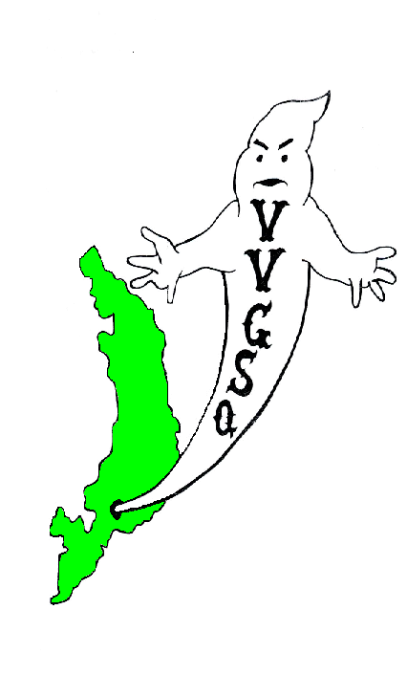
Vietnam Veterans Group of San Quentin

January 2012 General Meeting
Held in the Library on January 29, 2012.

EXECUTIVE COMMITTEE:

Chairman | Ron Self
Vice-Chairman | Barry Spillman
Secretary/Treasurer | Dave Basile
Outside Coordinator | Ron Self (Acting)
North Block Member-at-Large | Malcolm Jones
H-Unit Member at Large | Anthony Parker
West Block Member at Large | Harry Barton

Secretary Treasurer Basile called the meeting to order at 0800 hrs. Roll was called: 35 members present and 4 absent - there was a quorum. Our sponsor, Lt. K. Evans, was present. In addition, Operation Moms Representative Gloria Godchaux was present - thank you for joining us.

All present were asked to remove their hats for a moment of silence for those Missing-in-Action, those Killed-in-Action, and all other service members deployed in Iraq, Afghanistan, and around the world.

All members were asked if they received the December 2011 General Meeting minutes. All members did receive their minutes and no corrections were requested. A motion to accept the minutes was requested and the motion passed.

SECRETARY/TREASURER'S REPORT:
Mr. Dave Basile: We have $69.05 in our account as of 1/29/2012.

OUTSIDE COORDINATOR’S REPORT:
Mr. Self: The following correspondence received since our last meeting:

United Veterans of America Freeport, Florida
Chaplain Phillip Carter, NIV Savoy, Texas
Bill Anderson Seattle, Wash.
George Hoppen, Jewish war Veterans Boca Raton, Fla.
Herb Sallie Jr. Menlo Park, Ca.
Chaplin Caleb, USA, Vietnam Veteran North Carolina

COMMITTEE REPORTS:

BY-LAWS:
Chairman Bob Kaser: Nothing new to report.

TOY PROGRAM:
Chairman Baer stated the toy program was successful and wished to thank the US Marine Corp for there donation of toys. Thanks also to Chief Sponsor Lt. Evans for volunteering his vacation time to make the deliveries of toys and candy to the visiting room. Thanks to Veteran members Beavers, Barton, Faison, Gomez and Spillman for making the program a huge success. Final report from San Quentin’s Main Visiting Room showed 222 kids receiving toys.

SCHOLARSHIP:
Chairman J. Robinson: Introduction of the poster for the Scholarship Program was submitted with thanks to Veteran Snider for his time in drawing up the design. Sadly, the new poster may not be used due to the poor imagery when copied. The food selection process was tabled until old business.

VIP OFFICE:
Chairman Self introduced the transitional housing referral network’s ability to write a letter to the parole board indicating that the individual veteran has been pre-screened determining his eligibility or non-eligibility status. At this point, the VA office will issue a letter stating the pre-screening findings. This will allow the paroled veteran a destination to report too at which point he would be immediately housed. Mr. Self is currently in contact with Dr. Rosenthal, who is a VA representative out of Washington DC stationed in Marin County. The issue is to impress upon the VA as a “whole” the necessity in providing the appropriate wording within the letter, which will fulfill the transitional housing requirements for the Board. The next workshop is scheduled for March 16, 2012.

COLOR GUARD:
Chairman Trent Capell: The Flag Folding ceremony went well in presenting the flag to Collette Peck in honor of her husband Roland who passed away. Our Color Guard performed the ceremony at the services and get a huge “Well done”. Collette and Laura Bowman expressed their gratitude with the VVGSQ for their service in honoring the memory of Roland.

HISTORIAN/WEBSITE:
JLynn Manley was unable to attend the meeting, however, Lt. Evans was provided with the missing minutes that JLynn has requested in order to update our website.

STAMPS FOR SOLDIERS:
Mr. Rooke stated that he is getting signs for West Block, H-Unit and the Visiting Room

CAMARADERIE NIGHT:
Camaraderie night is officially on stand down until will get an approved sponsor.

PRESENTATION BOXES:
Chairman Schuhmacher stated that Machine Shop Vocational Instructor, R. Sanez, approved the engraving for the presentation box tops. Clip art pictures E-Mailed on Monday 1/30/12 by Lt. Evans were received by Mr. Sanez, which contain the logos for all military branches: however, there still seems to be a problem in which I believe will be resolved by our next meeting.

OPERATION MOM

Gloria stated that the 10-year aniversity went well with about 100 participants including parents of veterans and Goldstar Moms. This year the goal of the VVGSQ will focus on monetary donations as the mailing of boxes will be by special request only. The focus will be of assisting families of veterans who are suffering financial hardships.

OLD BUSINESS:

Secretary Basile conducted the voting on probationary member Dwight Adams. Sgt. of Arms passed out ballots and Lt. Evans tallied the votes. By a unanimous vote Dwight Adams was elected a member of the VVGSQ. Scholarship Banquet food selection process took place with the following entree’s: hamburgers, prawns, steak and potatoes, BQ chicken, lasagna and, Veteran Rookes’s old faithful selection, but never to this date fulfilled, fish and chips. Scholarship Chairman Robinson will speak to Food Manager Mearse about these selections and report next month the results.

NEW BUSINESS:

Secretary Basile had the following new members report: Veterans Goodlow, US Army, JD Martin, US Army, Stewart, US Army, Cooper, USMC, Tarvin, US Army, Johnson, US Navy, Farris, US Navy and Hernandez, US Army. All were welcomed and invited to participate in the VVGSQ’s worthy endeavors. Lt. Evans informed the group the the Wounded Veterans Baseball team would like to schedule a game against the SQ Giants on either August 18th or 25th. Ken Philpotts will be coordinating the gate clearances. Secretary Basile also informed the group that the Spooky pins and Scholarship pins arrived. It was agreed that Lt. Evans will submit trust withdrawals during the 3rd week of February and provide a good news list at which time that pins will be distributed. Trust withdrawals were made available and any completed ones must be given to Secretary Basile by February 18th in order to be processed this month..

Chairman Self thanked the Sponsors for attending on behalf of the entire group.

A motion to adjourn the meeting was made by Mr. Schuhmacher and was seconded by Mr. Baer. A vote was taken and the motion passed. The meeting adjourned at 0915 hrs.

UPCOMING EVENTS

February 26, 2012 | General Meeting in the Library @ 0800 hrs
March 25, 2012 | General Meeting in the Library @ 0800 hrs
April 29, 2012 | General Meeting in the Library @ 0800 hrs
May 27, 2012 | General Meeting in the Library @ 0800 hrs

Submitted,

__________________________ __________________
D. Basile, DATE
V.V.G.S.Q. Secretary / Treasurer

__________________________ __________________
R. G. Self DATE
V.V.G.S.Q. Chairman

NOTED

__________________________ __________________
K. Evans DATE
Correctional Lieutenant
V.V.G.S.Q. Chief Sponsor

Vietnam Veterans Group of San Quentin  San Quentin State Prison  1 Main Street  San Quentin, CA 94964-0001  Website: http://vvgsq.tripod.com/ | Chief Sponsor: Lt. K. Evans, (415) 454-1460 x 5205

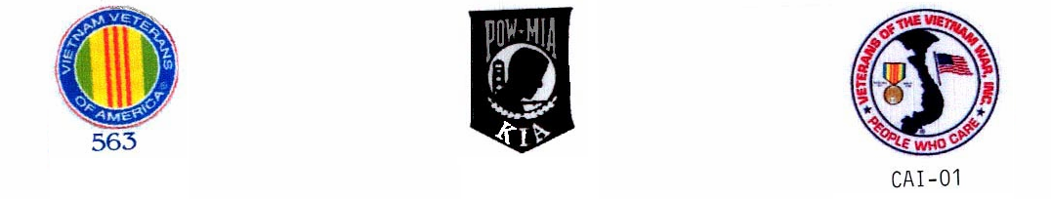
CURRENT ROSTER as of 1/29/2012

 |  | NAME | CDC # | HOUSE | ETH. | CUST. | STATUS | COMMENTS
1 | √ | ADAMS DWIGHT | K-98701 | 1N073L | BLK | MEDA | Voting Mbr
2 | √ | ARNOLD, RICHARD | P-27171 | 2N069U | WHI | CLOB | Voting Mbr | VIG
3 | √ | BAER, STAN | K-06285 | 3N039U | WHI | MEDA | Voting Mbr | VIG,
4 | √ | BARTON, HARRY | C-03120 | 1W037L | WHI | MEDA | Voting Mbr | VIG,W-Blk Mber @ Large,
5 | √ | BASILE, DAVID | C-70016 | 1N038U | WHI | MEDA | Voting Mbr | VIG, Secretary/Treasurer
6 | √ | BEAVERS, LAWSON | P-14974 | 1N015L | BLA | CLOB | Voting Mbr | VIG, Color Guard
7 | √ | BOTHA, GARY | D-88086 | 1N085L | WHI | MEDA | Voting Mbr | VIG, Scholarship
8 | √ | BROWN, DAVID | AE-3137 | 3W003L | BLA | MEDB | Voting Mbr
9 | √ | BUTLER, DUANE S. | D-91464 | 2N017L | BLA | MEDA | Voting Mbr | VIG
10 | A | CAFFALE, GEO | D-97941 | 3N008L | WHI | MEDA | Voting Mbr | VIG
11 | √ | CAPELL, TRENTON | E-91949 | 3N011U | BLA | CLOB | Voting Mbr | Chairman Color Guard
12 | √ | COOPER, GARY | T-15604 | 3W013L | WHI | CLOB | PROBATION | Probationary until 4/29/12
13 | √ | FAISON, POPEYE | C-68462 | 2N028U | BLA | MEDA | Voting Mbr | Probationary until 4/29/12
14 | √ | FARRIS, DARRYL | T-33812 | 5N071U | BLK | CLOB | PROBATION
15 | √ | GOMEZ, JOHNNY | K-72622 | 4N042L | MEX | CLOB | Voting Mbr
16 | √ | GOODLOW, KENNETH | C-75705 | 3W102L | BLA | CLOB | PROBATION | Probationary until 4/29/12
17 | √ | GUMPAL, MAURO | P-00591 | 4N036L | OTH | CLOB | Voting Mbr
18 | √ | HERNANDEZ, JESSE | K-21116 | 2W036L | WHI | MEDA | PROBATION | Probationary until 4/29/12
19 | √ | HICKMAN, HUGH | K-32967 | 03H035L | BLA | MEDB | Voting Mbr
20 | √ | JOHNSON, CRAIG | C-08327 | 4W063L | WHI | MEDA | PROBATION | Probationary until 4/29/12
21 | √ | JONES, MALCOLM | J-04780 | 4N008L | BLA | CLOB | Voting Mbr | VIG, NB Member at Large
22 | √ | KASER, BOB | D-41415 | 2N025L | WHI | MEDA | Voting Mbr | VIG, Chairman Bylaws
23 | √ | KESS, PHILLIP | G-62396 | 05H024L | BLA | MEDB | Voting Mbr
24 | √ | MARTIN, J.D. | D-44170 | 5W023 | BLA | MEDA | PROBATION | Probationary until 4/29/12
25 | A | PARKER, ANTHONY | D-20753 | 05H006L | BLA | MEDB | Voting Mbr | H-Unit Member at Large
26 | √ | POLLEY, AHMAD | C-57727 | 2W009L | BLA | MEDA | Voting Mbr | VIG, Color Guard
27 | √ | ROBINSON, GARVIN | K-52086 | 3N012L | BLA | CLOB | Voting Mbr | Scholarship Chairman, Color Grd
28 | √ | ROOKE, PETE | C-76159 | 1N020L | WHI | CLOB | Voting Mbr | Tabs/Stamps for Soldiers
29 | √ | SANDERS, GREG | E-05222 | 3W062l | WHI | MEDA | Voting Mbr | VIG, Outside Coordinator
30 | √ | SCHUHMACHER, CHRIS | T-31014 | 4N093L | WHI | MEDA | Voting Mbr | Presentation Box Chairman
31 | √ | SELF, RONALD | K-21055 | 4N083L | AMI | CLOB | Voting Mbr | VIG, VIP, Chairman
32 | A | SNIDER, JAMES | F-30077 | 5N008U | WHI | CLOB | Voting Mbr | Scholarship
33 | √ | SPILLMAN, GLEN | F-42695 | 3N035U | WHI | CLOB | Voting Mbr | VIG, Vice Chairman
34 | √ | STAUFFER, PAUL | T-80750 | 3N065U | WHI | CLOB | Voting Mbr
35 | √ | STEWART, NORFLEET | E-90026 | 4W079L | BLA | CLOB | PROBATION | Probationary until 4/29/12
36 | √ | TARVIN, DAVID | E-76518 | 2W038L | WHI | MEDA | PROBATION | Probationary until 4/29/12
37 | A | TREVENO, DANNY | J-93154 | 4W012L | AMI | CLOSB | Voting Mbr | Scholarship
38 | √ | VICK, ERNIE | P-59262 | 2N016L | WHI | CLOB | Voting Mbr | VIG, Scholarship
39 | √ | WARREN, JOHN | T-86358 | 04H065L | MEX | MEDB | Voting Mbr

√ = Present
E = Excused Absence
A = Unexcused Absence

